When it came to the projects, the one I was most interested in was the visual argument. Not only was it a topic I am passionate about, but it was also fun trying to figure out how to make my vision come to life. Now that I have thoroughly explained the reasoning behind everything, the only things I wanted to fix up were smaller things.

**ALL THE PICTURES BELOW WILL BE IN A**

**TOP PICTURE = BEFORE & BOTTOM PICUTRE = AFTER.**

Edit 1: Something that bothered me was that I wanted the image of people holding hands to be in front of the image of RCS. Everytime I tried to do that, the people would cover the word RCS or the sizing just wouldn’t work. So my first change was using the Eraser tool to remove the part of the people holding hands that would cover the word in the RCS image.

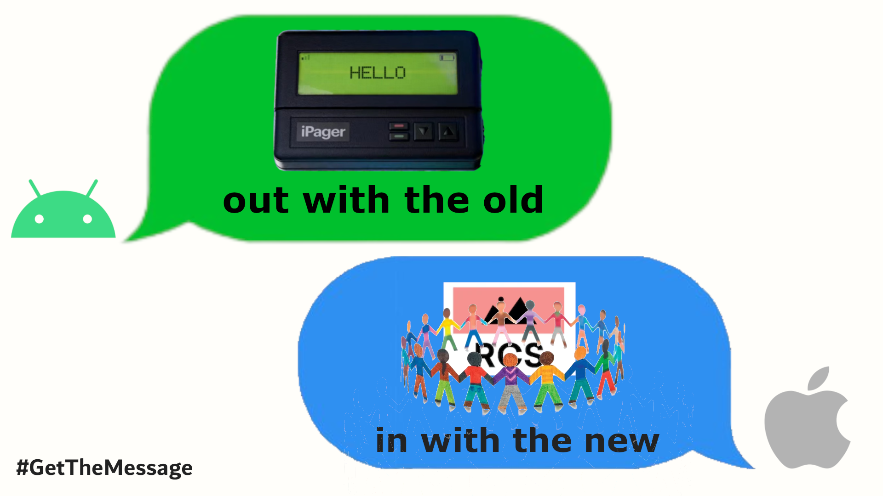

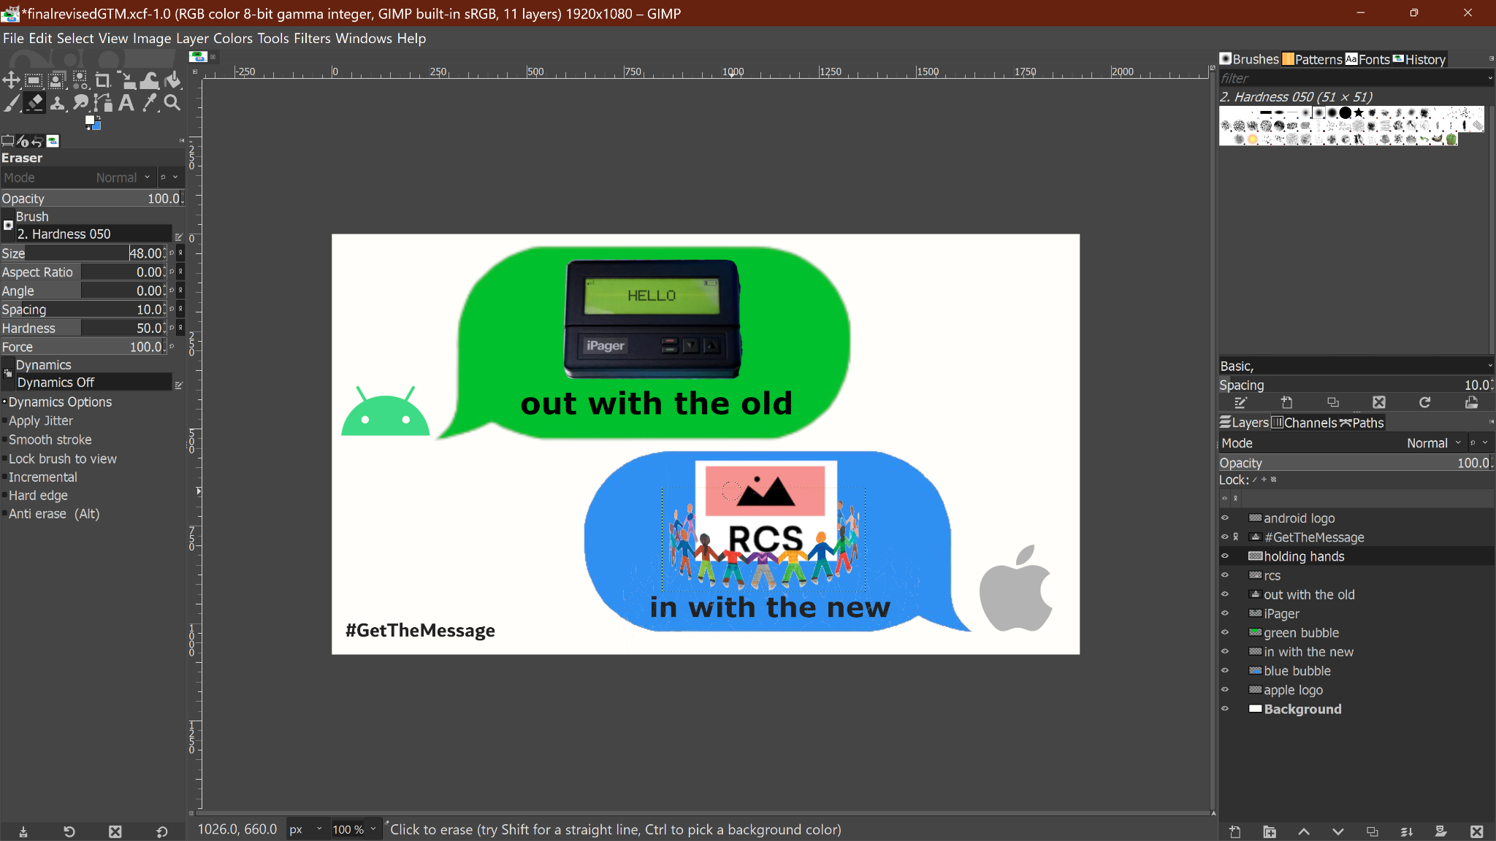

Edit 2: This was a very minor change, but I decided that the message bubbles were too close together and that the blue/Apple message bubble was further out from the corner than I liked. It wasn’t super noticeable but it was bothering me enough that I moved it further out, to make the padding/margins look more balanced on all sides.

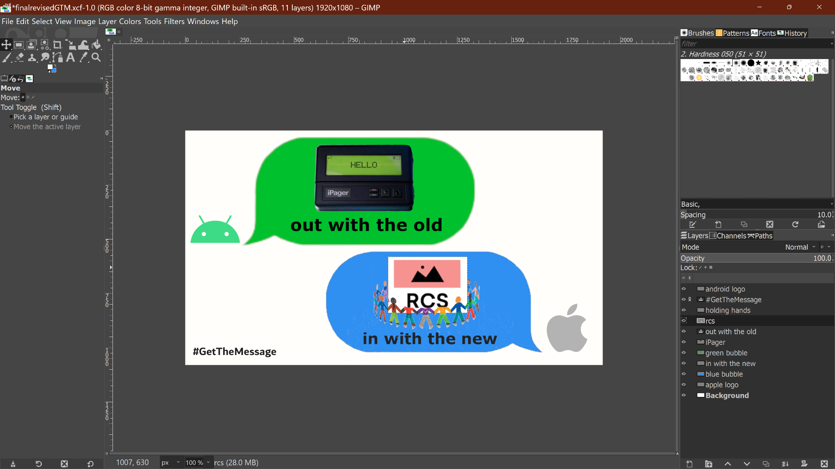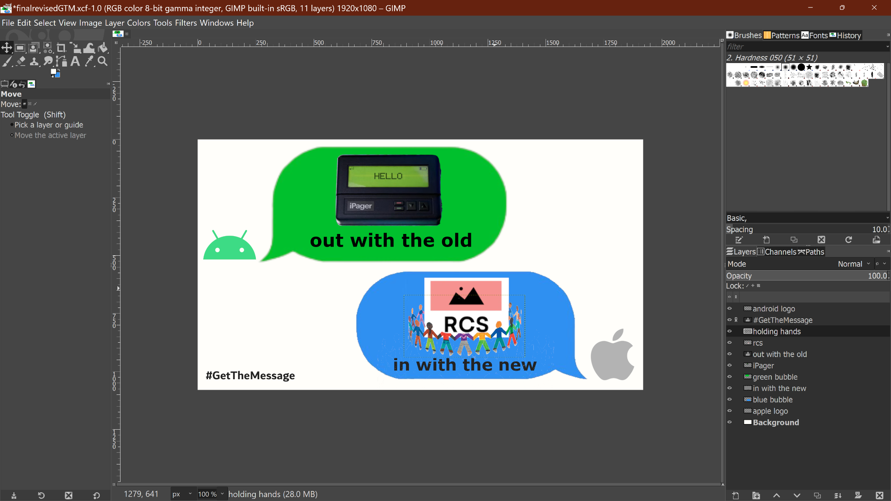

Edit 3: I really liked the video they made for the #GetTheMessage campaign where they made it look exactly like an Apple ad, using everything from their normal style to the super recognizable font they use. I wanted to mimic this, however; I couldn’t find a font close enough to Apple’s to make it seamless. After my final presentation where I showcased this project, Grace mentioned that using Apple’s font would be a great touch to bring it all together and make it better. This was an idea I wanted to implement all along and I decided I was going to make it happen! I looked up how to use fonts on Gimp, then went to download Apple’s font and found this on their site: <https://developer.apple.com/fonts/>. The type of file it downloaded was not compatible with my Windows laptop though, so I found a Github repo (<https://github.com/aishalih/sfwin>) that had the Windows friendly versions and used those. I still do not think it looks exactly like Apple’s but it is much closer and I am much happier with that. Figuring out how to upload fonts and where to even find system fonts was actually a really cool thing too, so I am glad I learned it!

